**LIGHT DEPENDENT RESISTORS**

<https://www.youtube.com/watch?v=IOyYQ34C2y0>

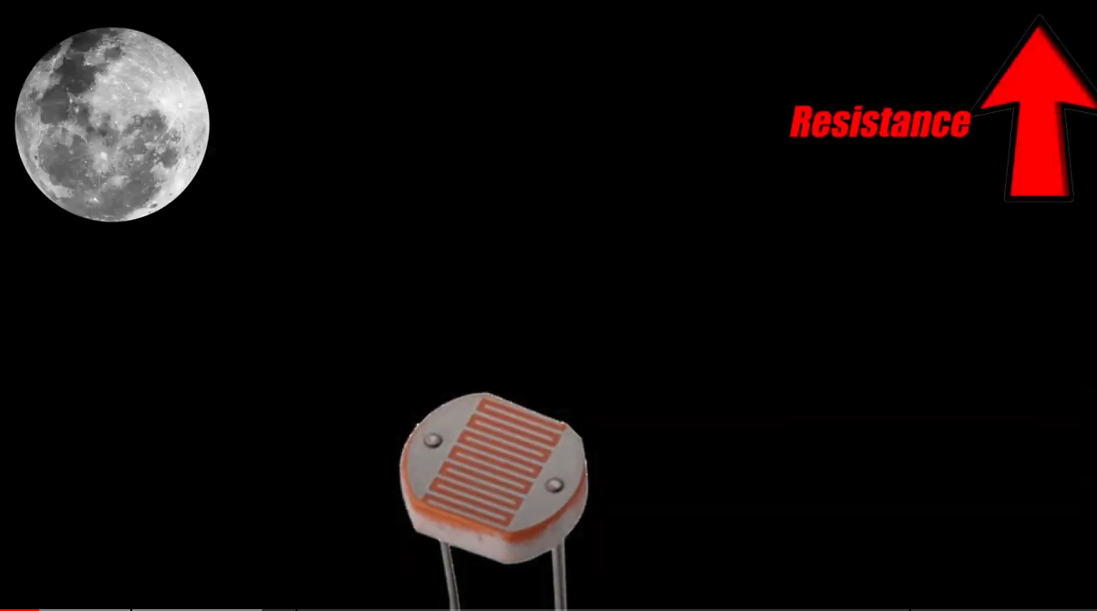

**DARK = THE LDR RESISTANCE TO CURRENT FLOW INCREASES**

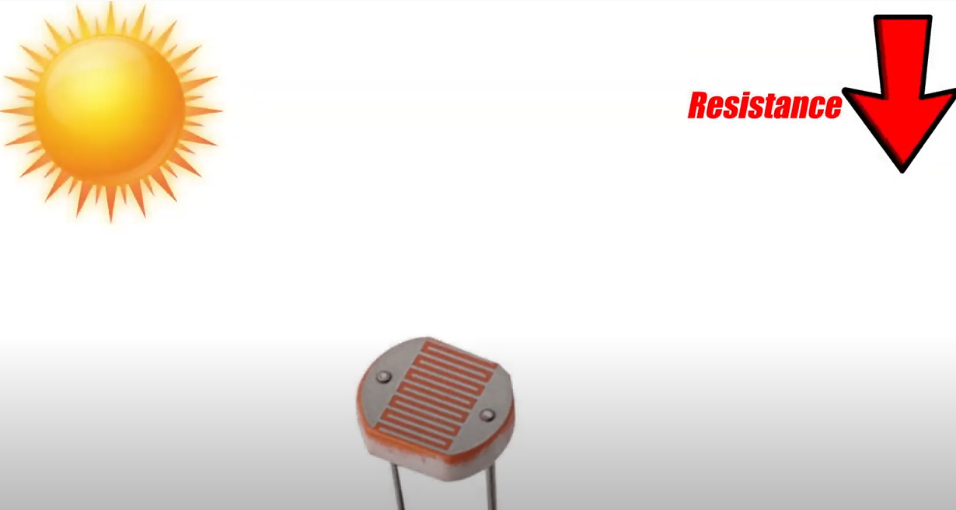

**BRIGHT = THE LDR RESISTANCE TO CURRENT FLOW DECREASES**

The Raspberry Pi has no analog pins through which we can measure voltage / current flow through the LDR. It has only Digital Pins which has only a ON value and a OFF value (1,0).

However, there is a clever, indirect way to measure the resistance to the current flow based on light falling on the LDR.

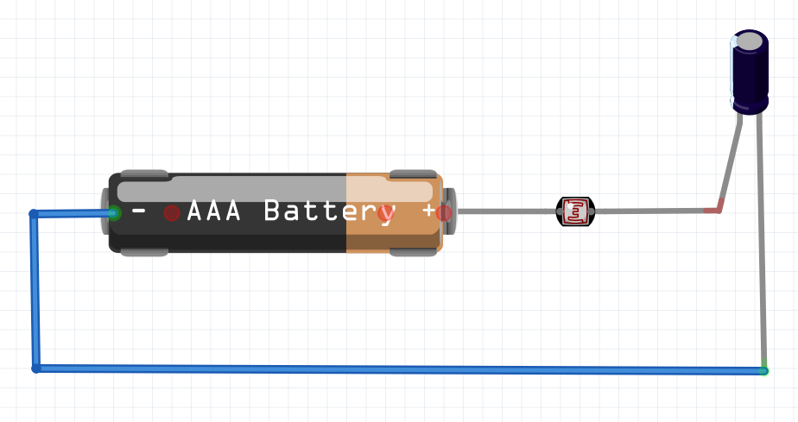

**INDIRECT MEASURING OF LIGHT INTENSITY**

**The time taken to fully charged the 10uF capacitor is relational to the amount of light falling on the LDR**



**10uF Capacitor**

We can indirectly measure the amount of light by connecting a capacitor. The amount of time taken for the capacitor to charge depends on how much current is flowing through the LDR attached to it. The lower the resistance of the LDR the faster the capacitor gets charged. Vice versa. This way can indirectly tell the intensity of the light hitting the LDR.

**Demo : ldrtest.py**

**Good Reference :**

[**https://pimylifeup.com/raspberry-pi-light-sensor/**](https://pimylifeup.com/raspberry-pi-light-sensor/)